**4.2 Hardware description: Finalising Set up components.**

**NodeMCU ESP8266:**

NodeMcu8266 is a development board which is built into ESP8266 wifi module. NodeMcu8266 is an Open Source Hardware device.

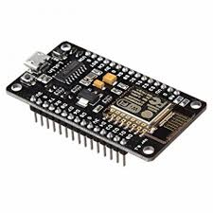

Fig: NOdeMCU.

**MQ-2 (gas sensor)**

* MQ2 gas sensor is an electronic sensor which is used for sensing the concentration of gases in the air such as LPG, propane, methane, hydrogen, alcohol, smoke and carbon monoxide. this sensor is also known as chemiresistor. In this sensor there is a sensing material whose resistance changes when it senses gas.

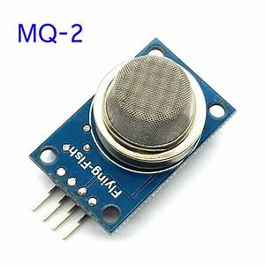

**Figure 19-MQ-12 gas sensor**

**.**

**MQ135 (gas sensor)**

* The MQ-135 Gas sensors are used in air quality control equipment and are suitable for detecting or measuring of NH3, NOx, Alcohol, Benzene, Smoke, CO2.

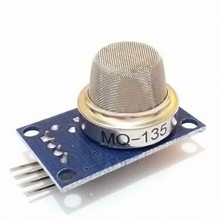

**Figure 20-MQ -135 gas sensor**

**Mq-7 (gas sensor)**

* Any signal when the sensor is shifted from clean air to carbon monoxide (CO), output signal measurement is made within one or two complete heating period (2.5 minute from high voltage to low voltage). Sensitive layer of MQ-7 gas sensitive components is made of SnO2 with stability, So, this sensor long term stability.

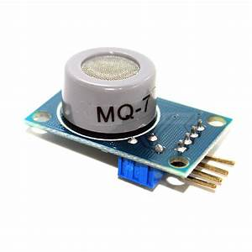

**Figure 21 - MQ - 7 gas sensor.**

**LM2596 dc-dc buck converter step down module with display board:**

 DC-DC Buck Converter Step Down Module LM2596 Power Supply is a step-down(buck) switching regulator, capable of driving a 3-A load with excellent line and load regulation. These devices are available in fixed output voltages of 3.3 V, 5 V, 12 V, and an adjustable output version.

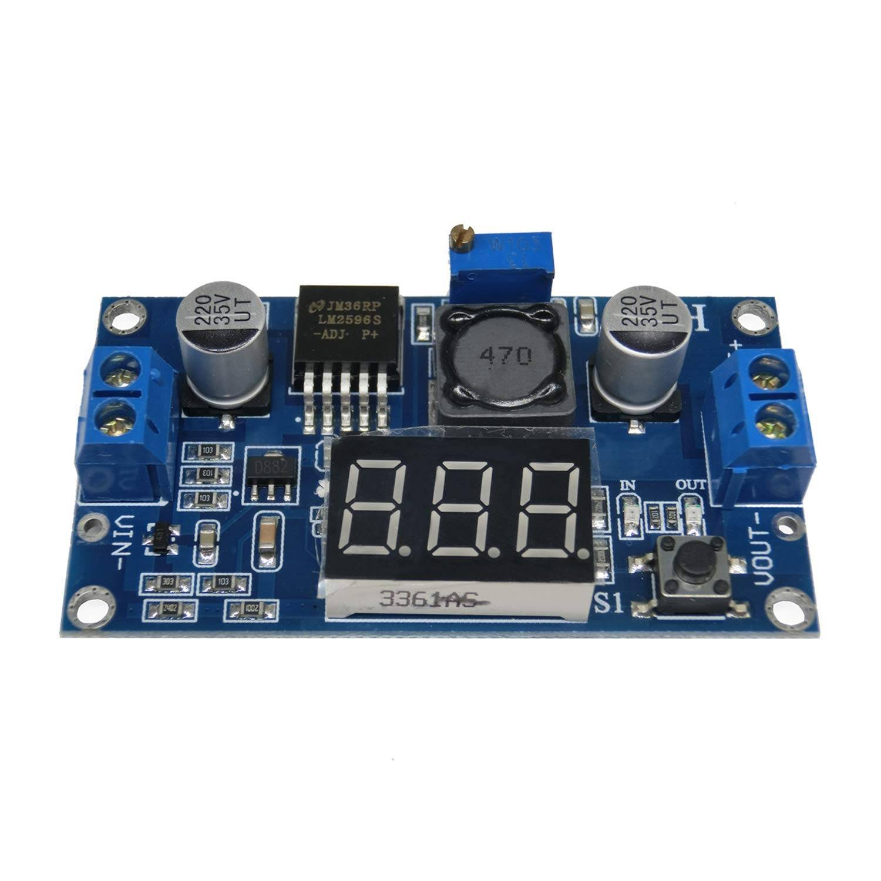

Fig: LM2596 dc-dc buck converter step down module.

**LDR 5mm photo resistor:**

This is a very small light sensor. A photocell changes (also called a photodetector, photo resistor, CdS or photoconductive cell) resistance depending on the amount of light it is exposed to.

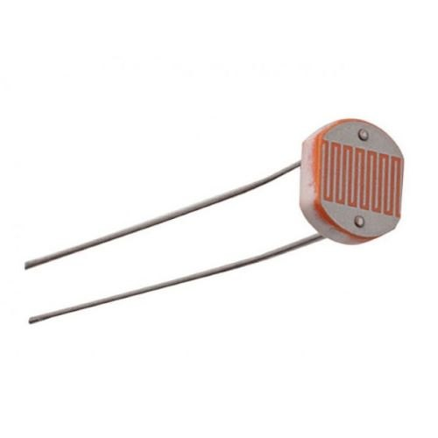

Fig: LDR 5mm photo resistor.

**220uF 16V**  **Electrolytic Capacitor**:

Aluminium **Electrolytic Capacitor**, which is a very high quality capacitor.

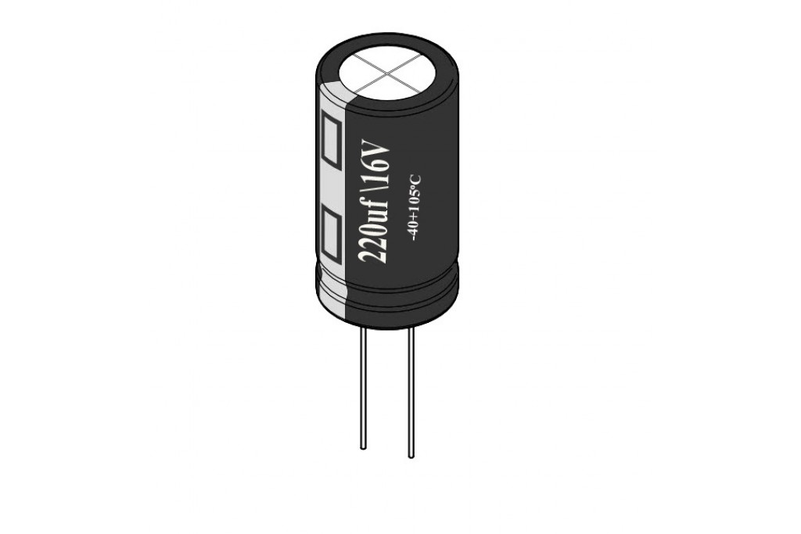

Fig: Electrolytic capacitor.

Multiplexor:

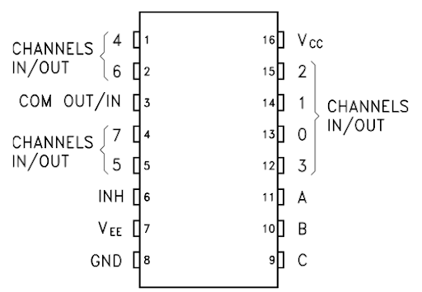

**Fig: Schematic of a multiplexor(ic).**

**4.3 Circuit Diagram (sensors)**

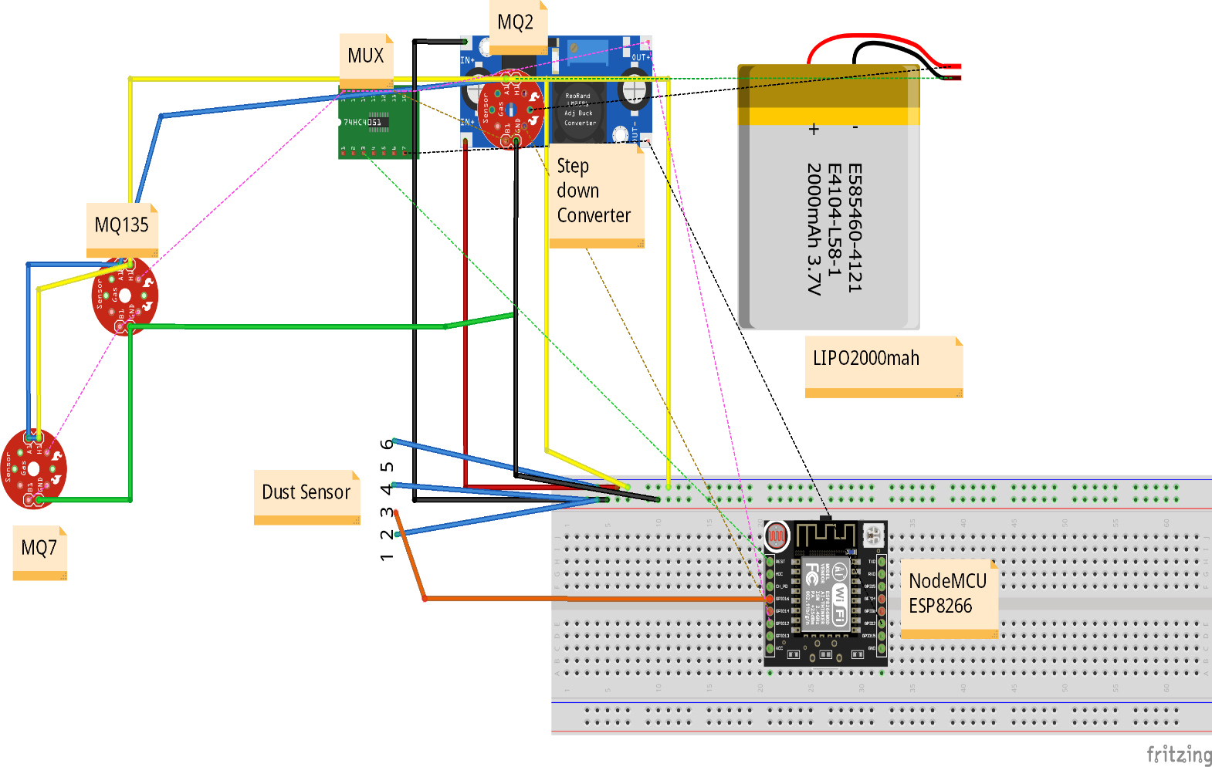

**Figure 22- Circuit Diagram**

We have made this circuit diagram with the help of fritzing software. Here we connected all the sensors with NodeMCU ESP8266, for sending data to the server. All labels are given.

**4.4 Circuit layout:**

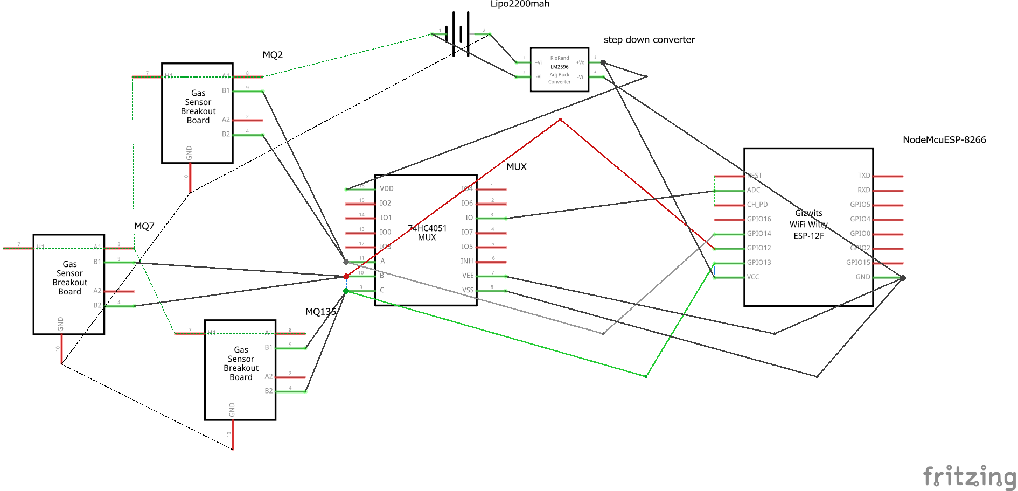

**Figure 23- Schematic Diagram (sensors)**

**4.5 Circuit Diagram (Drone)**

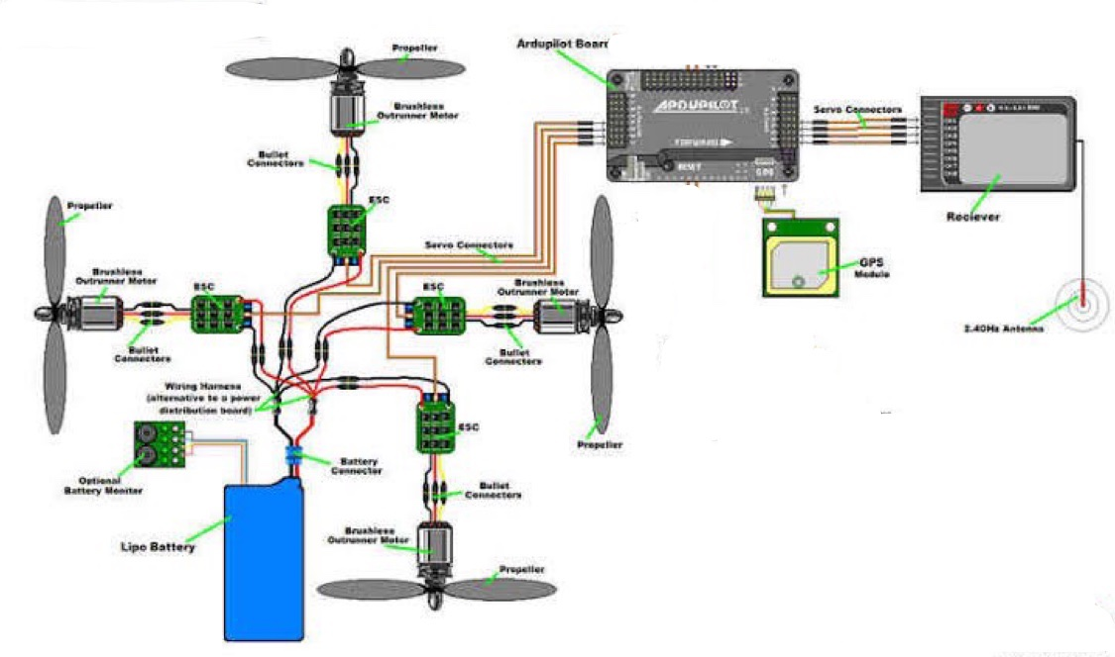

**Figure 24- Schematic Diagram (Drone)**